## A PROJECT REPORT ON

## Geo-BI DATA VISUALIZATION

## 

## M.Sc. Agriculture Analytics

## Submitted by: Nidhi Chaudhary- 202419004

## Priyanka Thakor – 202419013

## Submitted to: Dr. Kapil Oberoi

## (Geoinformatics Department)

## Space Research Organisation (ISRO ...

## Indian Institute of Remote Sensing

## Indian Space Research Organization

## Department of Space, Govt. of India Dehradun – 248001

## Uttarakhand, India

## April 2025

**TABLE OF CONTENTS**

*Table of Figures*

1. **Abstract**
2. **Introduction & Datasets**
3. **Study Area & Software used**
4. **Methodology**
5. **Result & Analysis**
6. **Conclusion**
7. **Future work**

*References*

**TABLE OF FIGURES**

**Figure 1** Study Area: Varedharna village

**Figure 2** Publishing tableau dashboard on webpage

**Figure 3** Harvesting date prediction window

**Figure 4** Present crop sown window

**Figure 5** Percentage of area covered by present crop

**Figure 6** Past sown crop window

**Figure 7**  Percentage of area covered by past sown crop

**Figure 8** Distribution of irrigation in Varedharna village

**Figure 9** Distribution of secondary occupation in Varedharna village

**Figure 10** Cropping Pattern window

**Figure 11** Cropping period window

**Figure 12** Harvesting pattern window

**Figure 13** Power BI visualization

### Abstract

The rapid advancement of big data technologies and geospatial analytics has opened new frontiers in precision agriculture and rural development. In regions where agricultural decisions are predominantly based on intuition or historical trends, data-driven decision-making can significantly enhance productivity, resource optimization, and sustainability. This project, titled "Geo-BI Visualization", is designed to explore how the integration of geo-tagged agricultural data with modern Business Intelligence (BI) tools—specifically Tableau and Power BI—can provide powerful insights into crop patterns, harvesting trends, and land-use dynamics.

The project focuses on visualizing large, heterogeneous datasets that include spatial coordinates, crop types, sowing and harvesting periods, and seasonal variations. Through the development of interactive and dynamic dashboards, users can intuitively explore and understand the temporal and spatial distribution of agricultural activities in rural areas. The core objective is to bridge the gap between raw geospatial data and actionable intelligence by creating user-friendly visual tools that can aid decision-makers—such as farmers, agricultural officers, planners, and researchers.

The Tableau dashboard, which serves as the primary visualization tool in this project, showcases various agricultural parameters including sowing and harvesting timelines, crop distribution, and seasonality. It employs map-based visualizations, filters, and interlinked charts to make complex data relationships easier to comprehend. Meanwhile, Power BI was used for supplementary analysis, focusing on tabular insights, comparative visualizations, and forecasting elements, albeit unpublished.

The Geo-BI Visualization project exemplifies the potential of integrating spatial data with analytical frameworks to support real-world decision-making in agriculture.

## Introduction:

## Dataset:

## The dataset was collected through a field survey conducted in VareDharna village to support the Geo-BI Data Visualization project focused on agricultural analytics. It contains essential information on farmers, including crop details, sowing dates, irrigation types, secondary occupations, and plot areas. Each record is uniquely identified with an ID and includes attributes such as the primary crop sown during the 2023 season (e.g., sugarcane, sweetcorn), contact information, sowing dates, and the intended harvesting dates (which currently contain placeholder values). Additionally, details about the secondary crops, quality of road access to farms, types of irrigation methods used (such as drip or flooding), market destinations for the produce, and secondary occupations like dairy farming are recorded. The dataset captures not only agricultural practices but also socio-economic factors, offering a holistic view of the farming community. Some fields have missing or incomplete data, suggesting the need for minor preprocessing. Overall, this dataset provides a strong foundation for spatial, temporal, and predictive analyses, helping to enhance decision-making in agricultural planning and rural development

**Project Objectives:**

The primary objectives of the Geo-BI Visualization project are:

* To perform spatial and temporal analysis of agricultural data using geo-tagged datasets.
* To develop intuitive dashboards using Tableau and Power BI that visualize patterns across time and geography.
* To forecast harvesting timelines by examining the relationships between crop types, sowing periods, and climatic or regional influences.
* To support sustainable rural planning by identifying agricultural hotspots and seasonal trends.
* To demonstrate the utility of integrating GIS with Business Intelligence tools for agriculture-centric big data analysis

## Study Area and Software used:

### Study Area:

The village of VarheDavna is situated in Maharashtra, India's Niphad tehsil within the Nashik district. It is located 20 kilometers from the district headquarters in Nashik and 20 km from the sub-district headquarters in Niphad (the tehsildar office). Varhedavna is the gram panchayat of Varhe Davna village, according to 2009 statistics. The community occupies 244 hectares of land in total. There are 1,545 people living in Varhe Darna overall, of whom 815 are men and 730 are women. Varhe Davna Village has a 66.60% literacy rate, with 61.51% of women and 71.17% of men literate. Varhe Davna village has roughly 326 dwellings in total. Varhe Davna village is run by a sarpanch, who is chosen by the villagers to serve as their representative in elections.

VarheDarna is small Village having all the basic technology and techniques to improve their farmlands. Village is well-connected to the roads and having market availability for goods to nearby location. In the village most of the families or Farmers has secondary occupation which includes Dairy and Poultry. Certainly farmer grows sugarcane and vegetables. Due to availability of water and market to sell their Goods, most of the farmer in the VareDharna preferred to grow or cultivate the vegetables

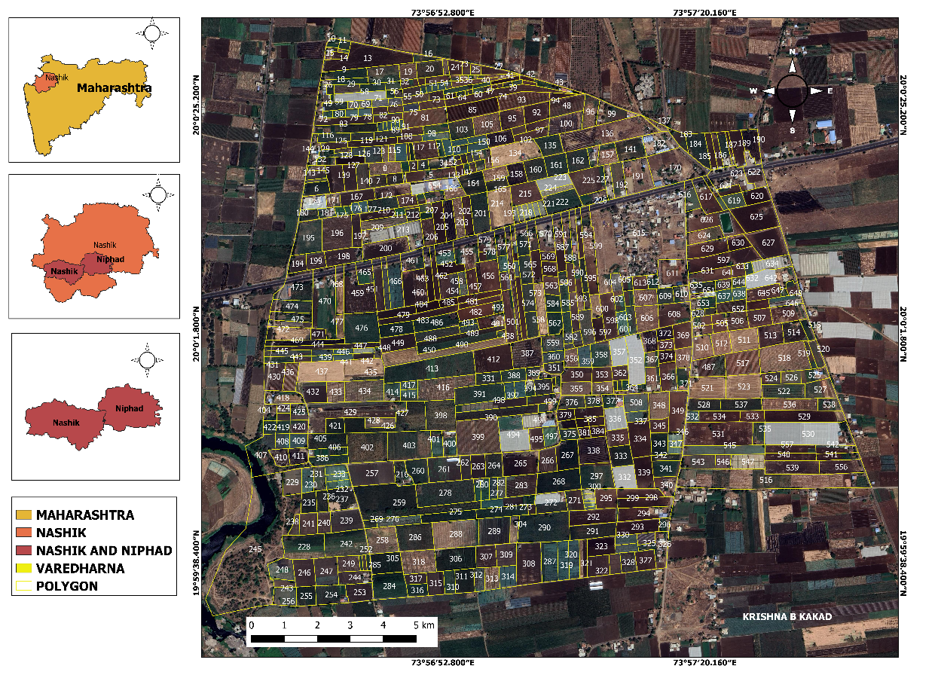

**Figure 1 Study Area :VareDharna village**

**Software Used:**

#### QGIS:

QGIS, also known as **Quantum GIS**, is a geographic information system (GIS) software that is free and open-source. QGIS supports Windows, macOS, and Linux. It supports viewing, editing, printing, and analysis of geospatial data.

#### Qfield:

The data that should be collected by team has gathered in QField may be merged and synchronized with QFieldCloud. QFieldCloud takes the headache out of data synchronization and merging, for both small-scale individual projects and large-scale data gathering campaigns.

#### Tableau:

**Tableau**is**a visual analytics platform that is revolutionizing the way we use data to solve problems by enabling individuals and organizations to make the most of their data.** Tableau is a platform for visual analytics that revolutionizes how we utilize data to solve issues. It gives people and businesses the ability to leverage their data to the fullest by offering simple, visual tools for organizing, sharing, and exploring insights

#### Map shaper:

Mapshaper is software for editing Shapefile, GeoJosn, CSV and several other data formats, written in JavaScript or Python. Mapshaper supports essential map making tasks like simplifying shapes, editing attribute data, clipping, erasing, dissolving, filtering and more.

**Anaconda Navigator (Jupyter Notebook):**

Anaconda Navigator is a desktop application that is built on top of the conda package and environment manager. Navigator enables you to use conda to manage environments and packages, but in a graphical application instead of a command line interface (CLI).

**Power BI:**

Power BI is a powerful data analytics and visualization tool used to transform raw data into interactive dashboards and insightful reports. It helps in analyzing trends monitoring real-time performance, and making data-driven decisions.

## Methodology:

Georeferencing of Cadastral map

Digitization of VareDharna village

Geo-Tagging Field survey

Creating fields in attribute table

↓

Mapshaper

Web Portal Architecture for Data Visualization

### Georeferencing of Cadastral map:

Cadastral digitization requires a georeferenced VareDharna of a cadastral as well as the polygon layer containing the cadastral boundary. Digitization of the cadastral involves splitting of the main polygon into individual features in QGIS.

Upload georeferenced VareDharna

Create polygon boundary of the cadastral

Use Split Feature to split entire polygon into individual plots

Start from one corner and end towards the other end

### Digitization of VareDharna village:

Digitization is the process of conversion of hard copy data or scanned data, whether it be maps or a physical cadastral, into computer editable vector formats, through the help of various software.

Create Shape file Layer (polygon)

Set Scale 1:5000 and lock it

Add Features to be Digitized

Right Click to confirm

### Geo-Tagging Qfield Field Survey:

In this method while performing the field survey the application provides coordinates in latitudes and longitudes and decimal points in field survey which can be used to pinpoint the location of the media on a map and also visualize the fields to be filled.

Open Data Project File in Qfield app

Data Collection

Push changes/data to the Backend

Storing collected Data

### Creating Fields in attribute table:

In **QGIS, Attribute table** is a fundamental component that displays information about features within a selected layer. Attribute table includes different fields which contains specific data about that feature.

Right Click on layer in QGIS

Open attribute table

Toggle editing (On)

Create New field

Rename the created fields and select the data type as per the field

### Mapshaper:

To convert the Shape file(.shp) to GeoJson, furtherly the GeoJson file . Firstly, the shape file is imported to the mapshaper Dashboard. The shape file is converted borders are fixed according to the required size and shape by using the method.

Import the Shape(.shp) file

Mapshaper fix the border and errors by method

Export spatial data file in the json Format

### Tableu server:

Tableau is a platform for visual analytics that revolutionizes how we utilize data to solve issues. It gives people and businesses the ability to leverage their data to the fullest by offering simple, visual tools for organizing, sharing, and exploring insights. Regardless of your role in the data exploration and analysis process—analyst, data scientist, student, educator, executive, or business user—Tableau prioritizes you. . I used data mining to eliminate every duplication as soon as the spatial data was connected to the Tableau server. Additionally, the visualization procedure uses the data.

Import Spatial data file which is converted into json

Datasource

Removal of duplicates and null values

Create Worksheet

Create Dashboard

### Creating Webpage for statistical data analytics:

This strategy involved designing a webpage that contains all of the statistical analysis of the provided data. Although the script is written in Python, the output is in HTML. The information is provided in the form of a thorough report. Several crucial lines of code are highlighted in the following script lines. (ydata_Profiling) is a module that converts the program into an HTML script and creates a report. Pandas works with numerical data and is employed in data mining as well as manipulation of the numerical data.(pd.read_csv) is used to connect to the console and call the file from its directory. Profile Report stores the link to the necessary device and generates a comprehensive report on the webpage (to_file).

*from ydata_profiling import ProfileReport*

*import pandas as pd*

*df = pd.read_csv(r"D:\case study\CASE STUDY 1\CASE STUDY.csv")*

*prof = ProfileReport(df)*

*prof.to_file(r"D:\case study\CASE STUDY 1\CASE STUDY.csv")*

### Publishing the Tableau dashboard as the Webpage:

Tableau offers the ability to publish or construct a web page dashboard using the backend support of Tableau Public, therefore making the dashboard accessible to all users. A dashboard that facilitates the creation of an eye-catching and imaginative webpage is presented on the website when developing or posting the worksheet location. The data visualization may be directly accessed or understood using the following links.

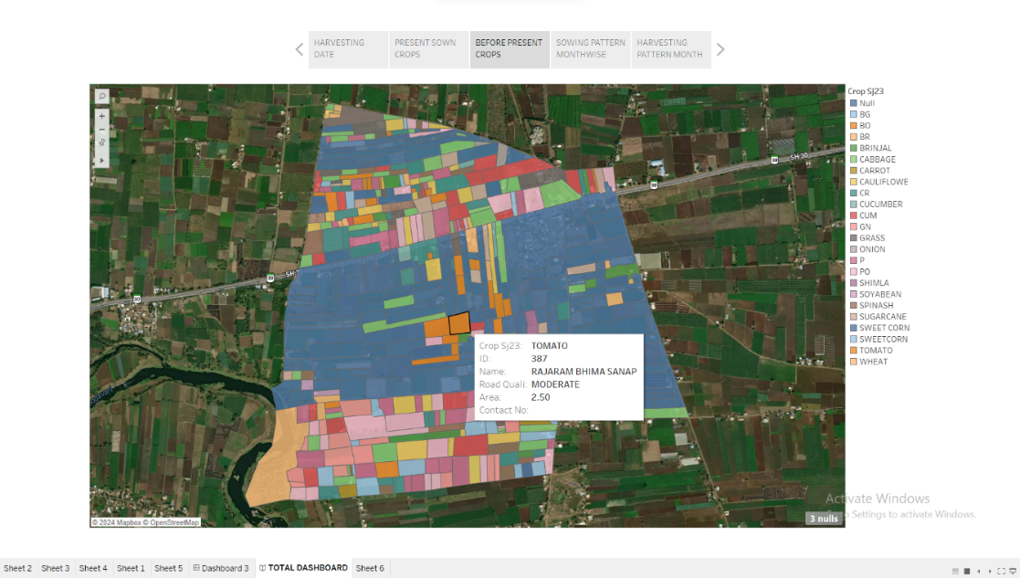

**Figure 2 Publishing the Tableau dashboard on Web page**

**Result and Discussion:**

**Harvesting Date Predication Window:**

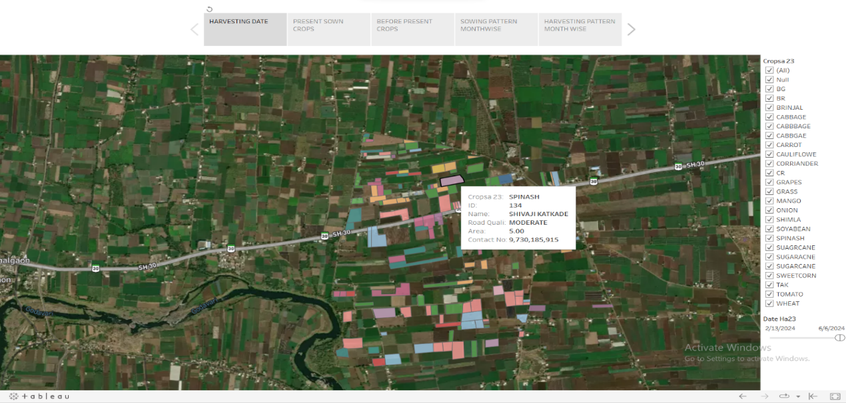

**Figure 3 Harvesting date Prediction Window**

An idea of the window may be seen in the aforementioned photograph. The inscriptions that establish parameters like the crop type and date are inserted on the right side. As a consequence, polygons are chosen based on crop composition. It may be used to determine which crops will be harvested in the near future. It also provides a detail information, if we will move the curser to that particular ID.

**Present Crop Sown window:**

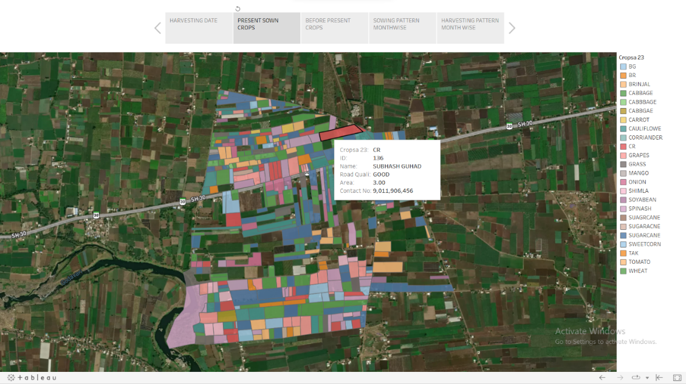

**Figure 4 Crop Sown window (Present)**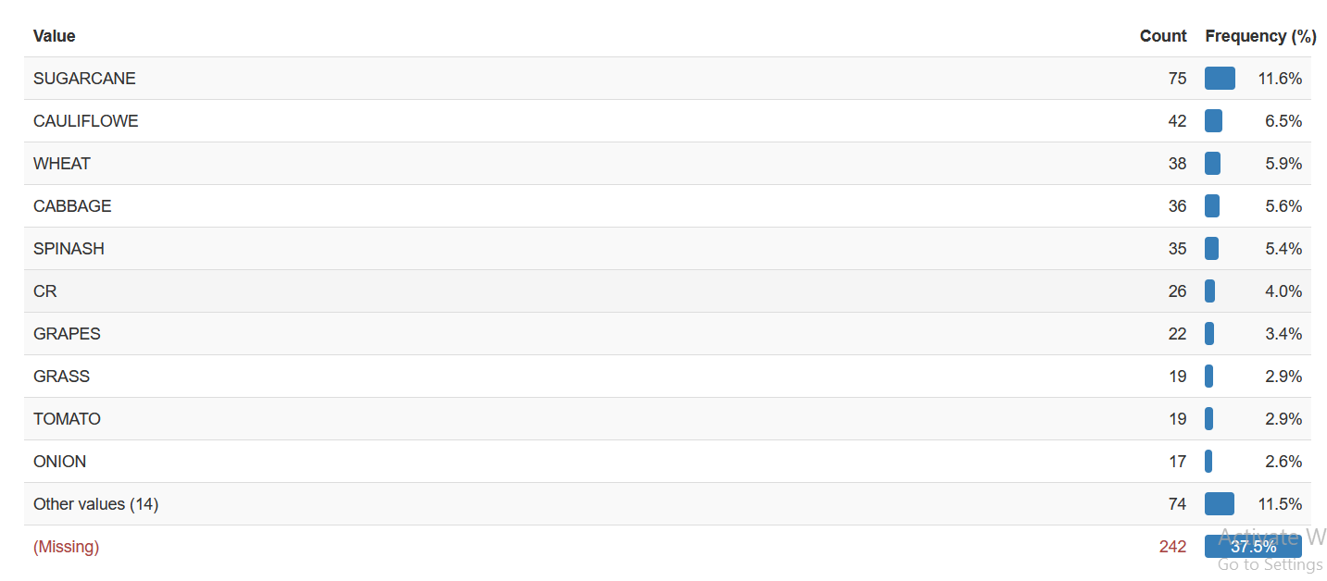

**Figure 5 Percentage of area covered by crop (Present)**

The output of the previously stated windows was a tabular bar chart with data on the VareDharna total area covered by the particular crop. Sugarcane has been planted in more plots than other crops; according to data collection figures, it makes up around 11.6% of the total area. It gives particular information about the land cover percentage for each crop, for example, 6.5%, 5.9%,5.6%,5.4%,4.0%,3.4%,2.9%,2.9%, and 2.6% for onions, tomatoes, grapes, cauliflower, wheat, cabbage, spinach, and cilantro, respectively.

**Past Crop Sown window:**

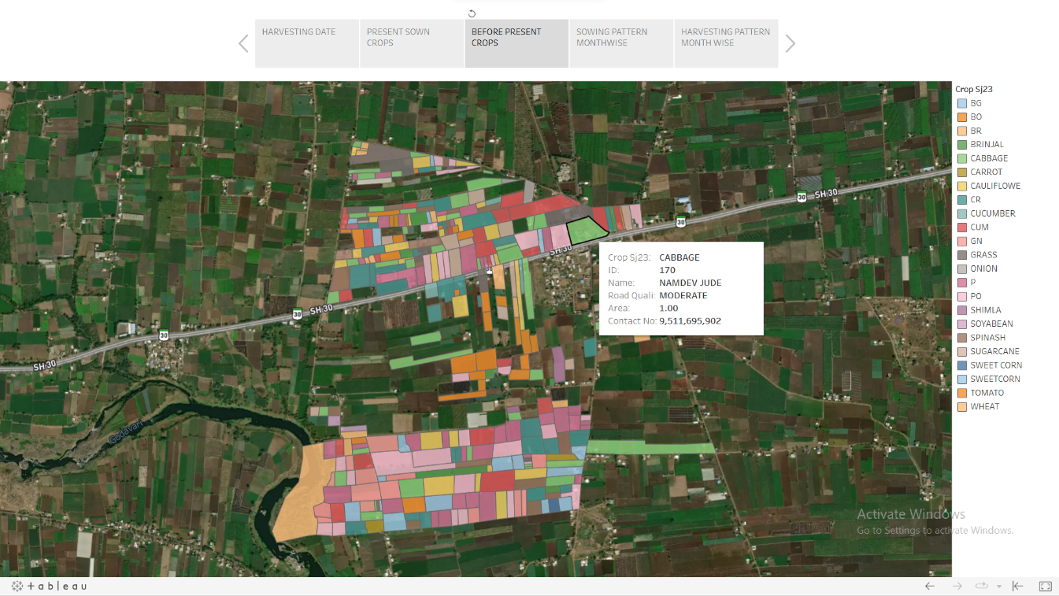

**Figure 6 Past Crop Sown Window (Past)**

The output of the previously stated windows was a tabular bar chart with data on the VareDharna Village area covered by each particular crop. Cabbage has been planted in more plots than other crops; according to data collection figures, it makes up around 6.5% of the total area. The following are some specifics on the land cover by crop: 6.4%, 5.0%,4.7%,4.3%,4.3%,3.6%,2.8%,2.3%,2.2% for cauliflower, wheat, sugarcane spinach, cucumber, potatoes, coriander, and fallow land, respectively.

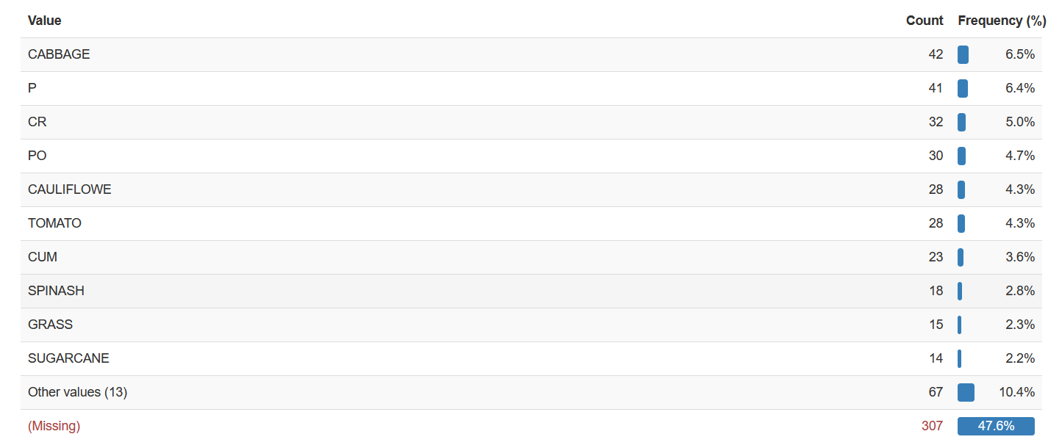

**Figure 7 Percentage of area covered by crops (Past)**

**Irrigation System of VareDharna Village :**

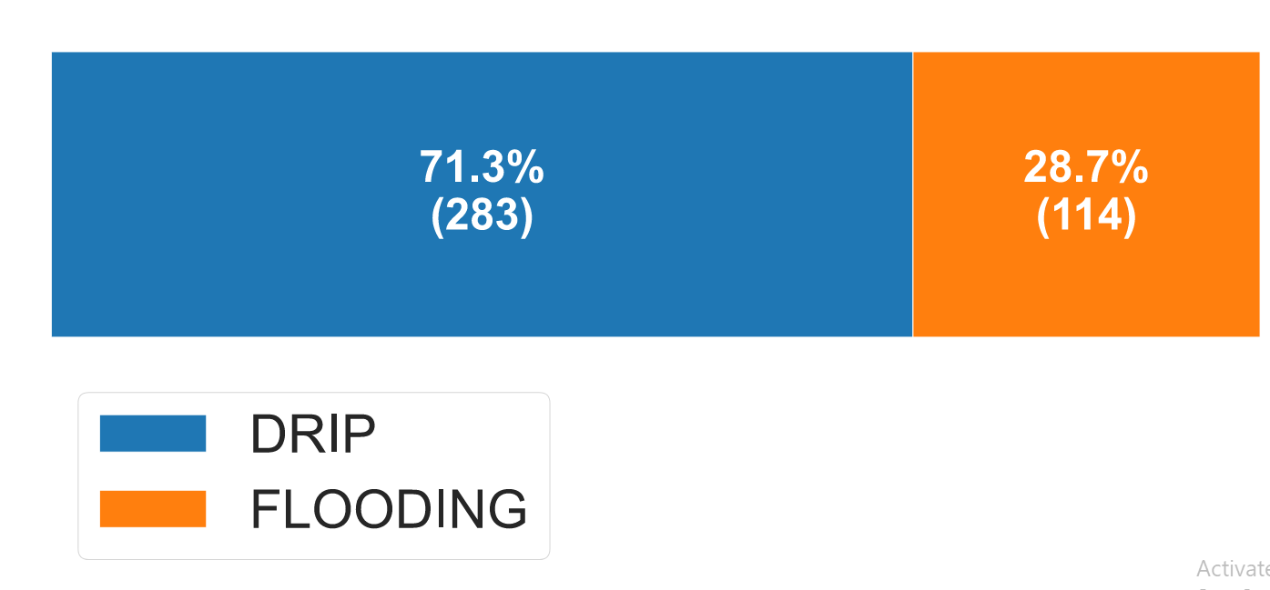

**Figure 8 Distribution of irrigation in VareDharna village**

Information regarding the irrigation system, which is divided into two categories drip and flooding is revealed in the plot given above. Approximately 71.3% of farmers have installed drip irrigation systems, whereas 28.7% of people water their property using the traditional method of flooding. Flooding mostly affects farmers who grow crops like sugarcane and green vegetables. The above graphic provides a comprehensive image of VareDharna village's irrigation allocation.

**Secondary Occupation distribution In VareDharna Village:**

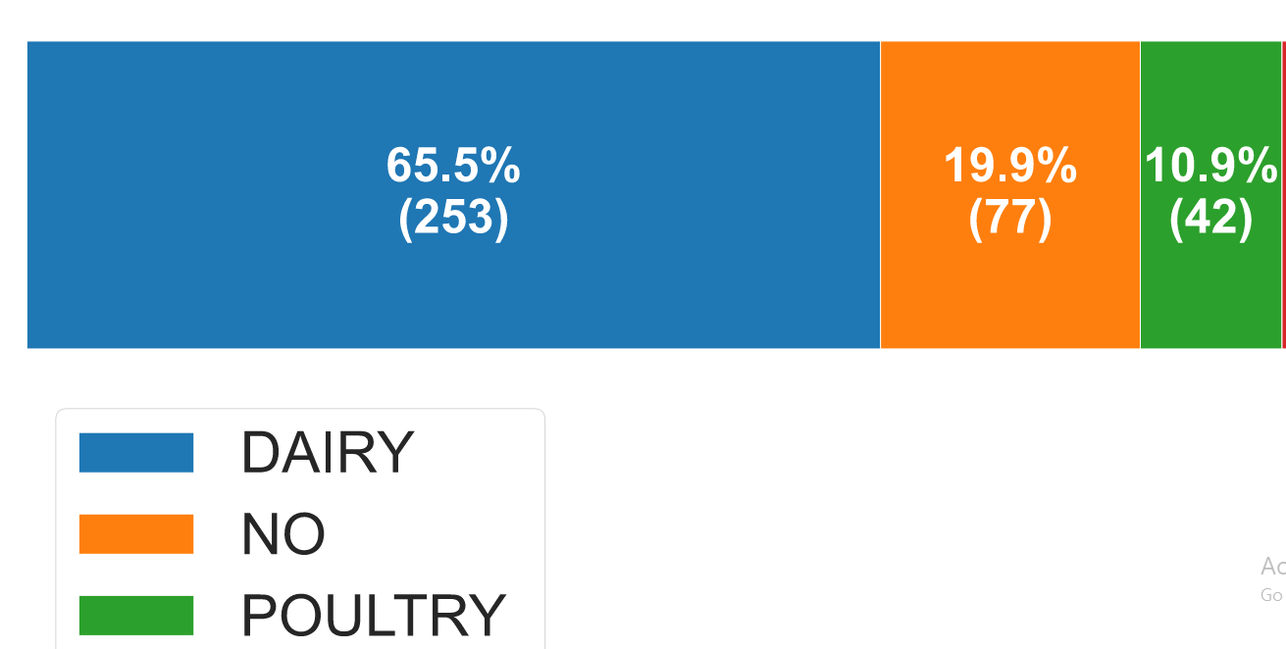

**Figure 9 Distribution of Secondary Occupation in VareDharna Village**

Information on the secondary occupation in VareDharna hamlet is depicted in the plot mentioned above. It indicates the proportion of farmers, dairy farmers, and poultry farmers who do not have a second occupation. Farmers that own cows on their property are known as dairy farmers. According to the data displayed, dairy shares around 65.5% of all other related occupations. The percentages for poultry and non-allied occupations are 19.9% and 10.9%, respectively.

**Cropping Pattern Analysis:**

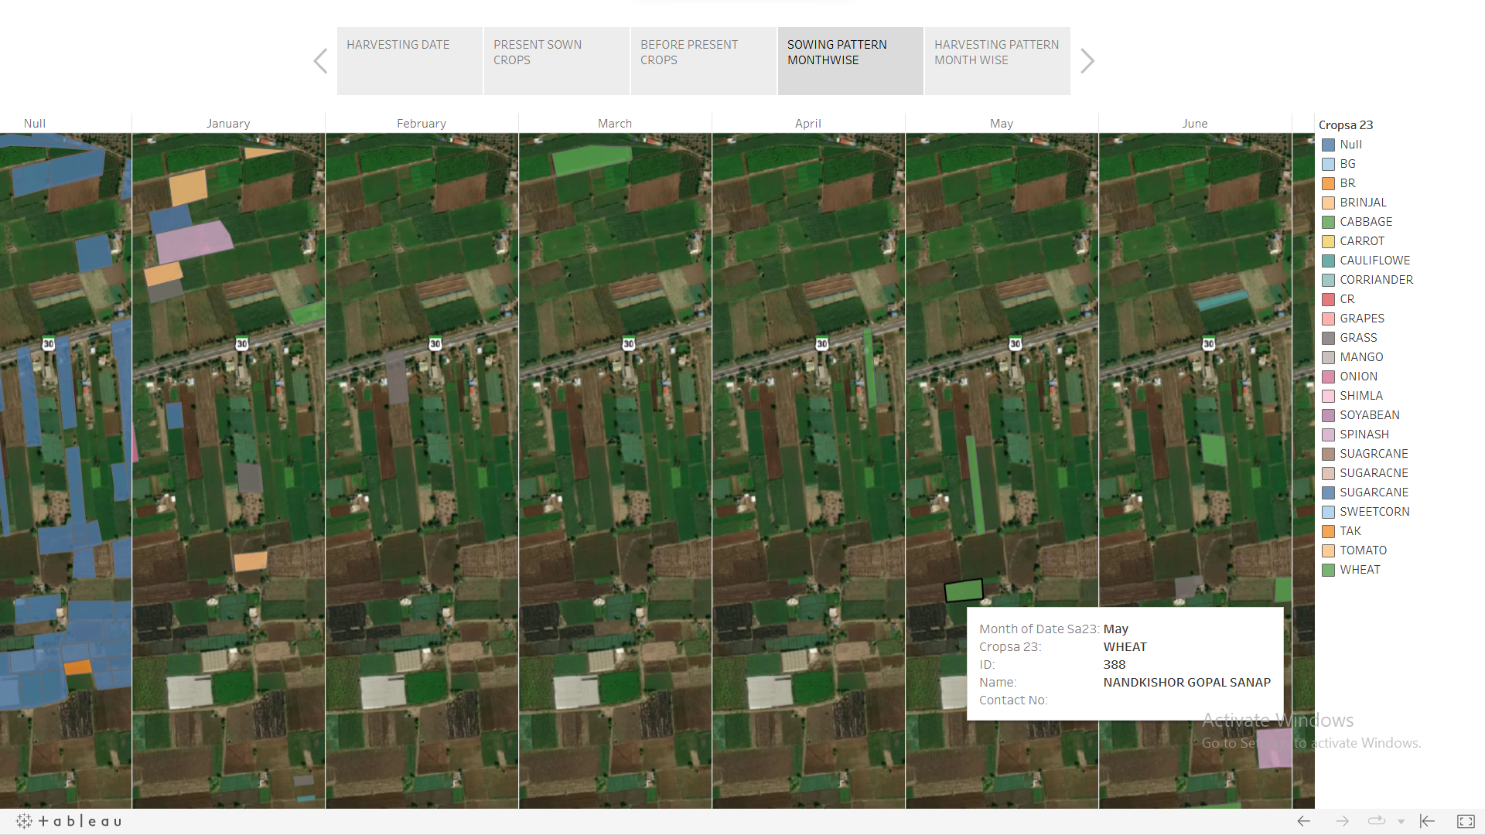

**Figure 10 Cropping Pattern Window**

The cropping pattern of all the aforementioned crops in VareDharna village is described in this window. It provides a thorough examination of the cropping schedule for this cropping season, broken down by month from January 2023 to December 2023.Through which it is extremely simple and convenient to determine the cropping pattern based on the months, and it provides information about that specific plot or polygon while choosing it.

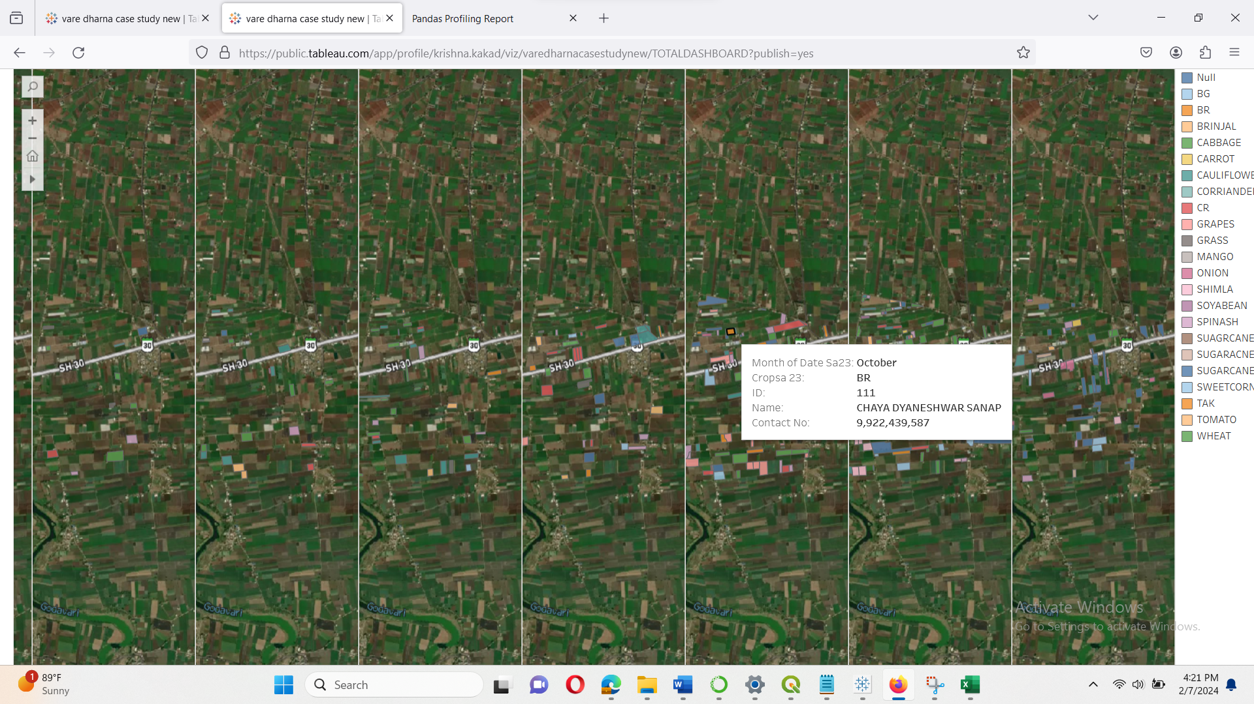

**Figure 11Cropping Period**

From October, November, and December are the best months to plant all crops, according to the analysis of agricultural patterns. These three months are when sugarcane, brinjal, bittersweet potatoes, cucumbers, and other vegetables are Sown. Leafy vegetables are typically seeded for around six months, from March to August. Sugarcane is primarily sown in the months of December and January since it is the most important crop among all others. This window provides detailed information on the crops that are being sown.

**Harvesting Pattern Analysis:**

The Harvesting pattern of all the aforementioned crops in VareDharna village is described in this window. It provides a thorough examination of the Harvesting schedule for this cropping season, broken down by month from January 2024 to December 2024.Through which it is extremely simple and convenient to determine the Harvesting Pattern based on the months, and it provides information about that specific plot or polygon while choosing it.

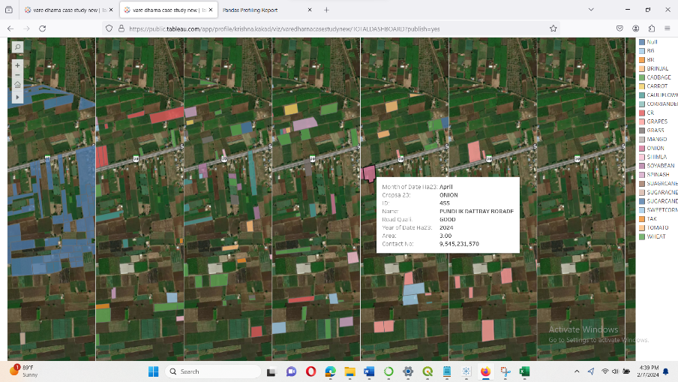

**Figure 12Harvesting Pattern Window**

**Power BI Visualization:**

**1. Total Area Covered by Different Crops – August 2023 (Bar Chart)**

* This horizontal bar chart illustrates the total land area (in acres) covered by various crops sown in August 2023.
* SUGARCANE emerges as the most widely cultivated crop, occupying the maximum land area.
* It is followed by CAULIFLOWER, CABBAGE, WHEAT, and SPINACH.
* Some inconsistencies such as repeated entries (CABBAGE appears multiple times), abbreviations (CR, BG, BR, TAK), and blank values indicate the presence of data quality issues that need to be resolved for accurate interpretation**.**

**2. Crop Cover Distribution – August 2023 (Pie Chart)**

* This chart displays the percentage-wise distribution of crops cultivated in August 2023.
* The crop with the largest share covers 18.61% of the total sown area.
* Other significant crops contribute between 10–9%, while some have minimal contributions (e.g., 0.5%, 0.74%).
* The chart highlights major crops like WHEAT, TOMATO, SWEETCORN, and TAK, helping identify their proportional dominance.

**3. Crop Cover Distribution – January 2023 (Pie Chart)**

* This pie chart presents crop coverage data for January 2023, allowing for a seasonal comparison.
* The chart reveals a more balanced crop distribution, with several crops sharing between 8% to 12% of total land use.
* No single crop dominates the landscape, unlike in August, suggesting higher crop diversity during the winter season.

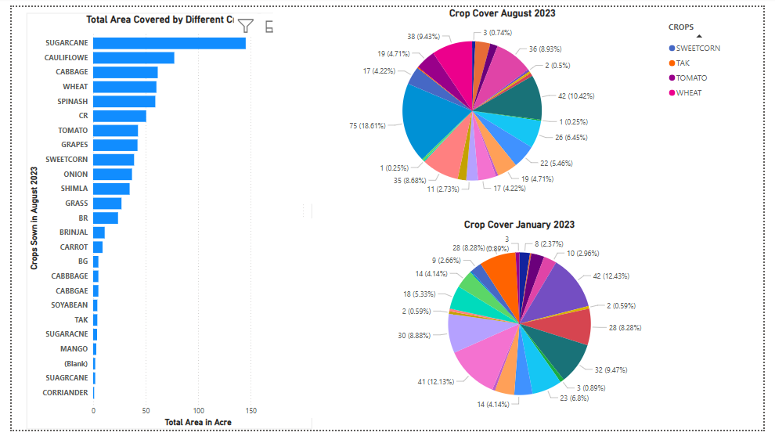

**Figure 13 Power BI Visualization**

**ADVANTAGES OF TABLEAU vs. POWER BI**

|  |  |  |
| --- | --- | --- |
| **Feature** | **Tableau Dashboard** | **Power BI Dashboard** |
| **Great for Maps & Spatial Data** | Perfect for showing farm plots, village maps, and crop locations with visual clarity. | Works for simple maps but not ideal for detailed geospatial analysis. |
| **Interactivity** | Very interactive – lets you click, filter, and explore easily. | Offers good interactivity for charts and summaries. |
| **Beautiful Visuals** | Dashboards are visually appealing and easy to understand at a glance. | Clean and neat visuals, great for business-style charts. |
| **Easy Online Sharing** | Dashboards can be published on the web and accessed by anyone. | Web publishing wasn’t used in the project, but it’s possible with extra setup. |
| **Insightful Summaries** | Helps tell a story with maps, crop cycles, and patterns. | Quick to build comparison charts – great for month-to-month or seasonal summaries. |
| **User-Friendly Design** | Once set up, very intuitive for exploring farming trends. | Easy for beginners to create simple reports and overviews. |

**Conclusion:**

The *Geo-BI Data Visualization* project successfully demonstrates the integration of geospatial data with modern Business Intelligence (BI) tools like Tableau and Power BI to visualize and analyze agricultural patterns. By applying GIS techniques (QGIS, ), database management and interactive dashboards (Tableau, Mapshaper), the project achieved spatial and temporal mapping of crop sowing, harvesting trends, irrigation systems, and secondary occupations in the VareDharna village.The predictive model helped forecast harvesting timelines, while data visualization dashboards simplified complex agricultural datasets into user-friendly insights for farmers, planners, and researchers.The project highlights the transformative potential of data-driven agricultural management, promoting sustainable practices and aiding decision-making at the village level.

**Future Work:**

* **Integration of IoT Sensor Data:** Real-time soil moisture, temperature, and rainfall data from IoT devices could enhance precision in crop prediction and resource management.
* **Incorporating Satellite Imagery:** Including Sentinel-2 or Landsat imagery for continuous vegetation monitoring and NDVI analysis would broaden the scope beyond ground surveys.
* **Machine Learning Enhancements:** Deploying ML models (like Random Forest, XGBoost) for yield prediction, pest risk forecasting, and crop classification.
* **Scaling to Regional Levels:** Expanding the approach to larger districts or states for policy-making and agricultural advisory services.
* **Advanced Forecasting Techniques:** Using Time-Series models (ARIMA, LSTM) for better forecasting of crop cycles and market trends.

**References**

1. Mishra, D., & Tripathi, S. (2017). *Big Data Analytics and Visualization Techniques: A Case Study from Agriculture Domain.* Retrieved from <https://www.researchgate.net/publication/320889200_Big_Data_Analytics_and_Visualization_Techniques_A_Case_Study_from_Agriculture_Domain>
2. Ghosh, S., & Roy, R. (2023). *Applications of Geospatial and Big Data Technologies in Smart Farming.* In S. R. K. Prathap (Ed.), Emerging Trends in Smart Agriculture (pp. 139-159). Springer. <https://www.researchgate.net/publication/368642139_Applications_of_Geospatial_and_Big_Data_Technologies_in_Smart_Farming>
3. Yang, C., et al. (2021). *Big Data and Its Applications in Agro-Geoinformatics.* In *Big Data Science for Smart Cities* (pp. 139-160). Springer. <https://link.springer.com/chapter/10.1007/978-3-030-66387-2_8>
4. Wei, W., Liu, D., & He, B. (2014). *Geo-Visualization of Agricultural Products Price Data Based on WebGIS.* Applied Mechanics and Materials, 513-517, 1899–1902. <https://www.scientific.net/AMM.513-517.1899>
5. Sundararajan, S., & Raj, E. (2019). *Data Visualisation for Smart Farming Using Mobile Application.* Retrieved from <https://www.researchgate.net/publication/338254421_Data_Visualisation_for_Smart_Farming_Using_Mobile_Application>